


SIMATS ENGINEERING
SAVEETHA INSTITUTE OF MEDICAL AND TECHNICAL SCIENCES
DEPARTMENT OF CSE

BRANCH : CSE
COURSE CODE : DSA0201
COURSE NAME : COMPUTER VISION WITH OPENCV FOR ROBOTICS AND AUTOMATION

ASSIGNMENT NO: 2

S.No | Question | Mark | CO | BL
1 | Each pixel value in 500 × 500 pixel image I is an independent, normally distributed random variable with zero mean and standard deviation one. Estimate the number of pixels that, where the absolute value of the x derivative, estimated by forward differences (i.e., |Ii+1,j − Ii,j|, is greater than 3. | 10 | CO2 | K3
2 | How the LBP can be affected by pre-processing, showing the compare threshold value effects. (Left) Compare threshold = 5. (Center left) Compare threshold = 10. (Center right) Original data after Laplacian fitler applied. (Right) Compare threshold = 5 on Laplacian filtered data | 10 | CO2 | K3
3 | Find the Convolutional filter for the sharpen kernel mask in the given object pixels is intended to amplify the center pixel in relation to the neighboring pixels. Each pixel is multiplied by its kernel position, and the result (right image) shows the center pixel as the sum of the convolution, which has been increased or amplified in relation to the neighboring pixels.  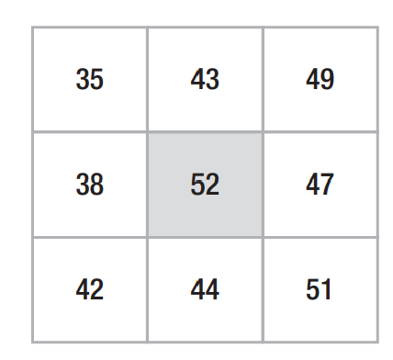 | 10 | CO2 | K3
4 | A template is moved over the whole image A(5,9,87), B(0,232,229),C(186,242,64). The pixel in the centre of the template is set to the average value of all the pixels in the template. With larger templates the noise is reduced more, but less detail is kept. Find the center value by using averaging method. | 10 | CO2 | K3
5 | Take a camera with an off-the-shelf lens. Design and perform an experiment to find the intrinsic calibration parameters of it. Design and use an appropriate calibration object (for example, a grid like structure printed by laser printer on paper; you might capture it at different heights by placing it on a box of known height). Discuss the precision of your results. Is the pinhole model of your camera appropriate? | 10 | CO2 | K3

